|  |  |
| --- | --- |
| **Name of the Dataset:** | Drug Classification |
| **Link to the Dataset:** | https://www.kaggle.com/datasets/prathamtripathi/drug-classification?resource=download |
| **Number of Attributes:** | 6 |
| **Number of Samples:** | 200 |
| **List of Attributes and Types:** |  |

**Student name:** Osama Mohammed Abuzraiq

**Student ID:** 202010646

* Importing Libraries and reading the file:

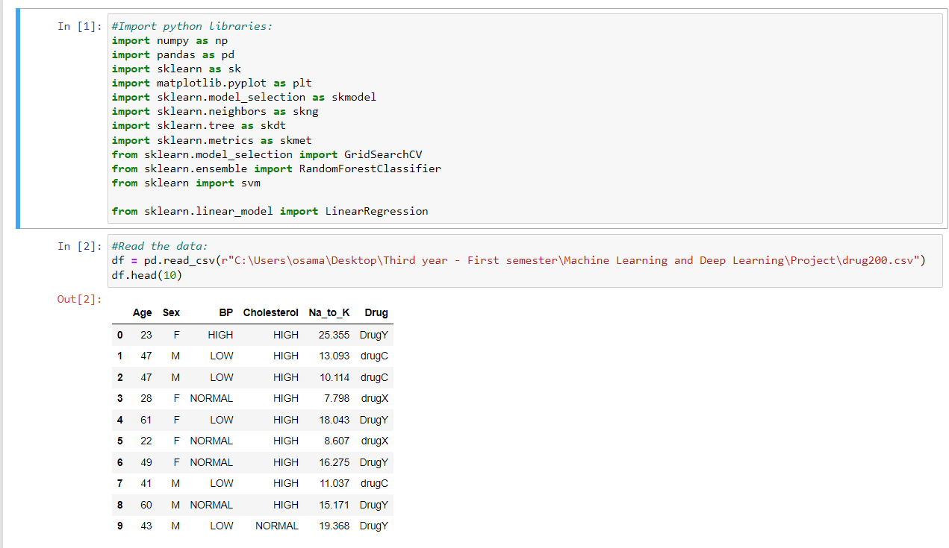

* Tuning data and separating features to training and testing

* **Nearest Neighborhood Classification (KNN =4)**

* **Results and confusion matrix:**

* **SVM Classification:**

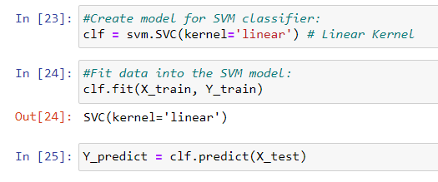

* **Results and confusion matrix:**

* Random Forest Classification:
* Hyper Parameter Tuning for random forest

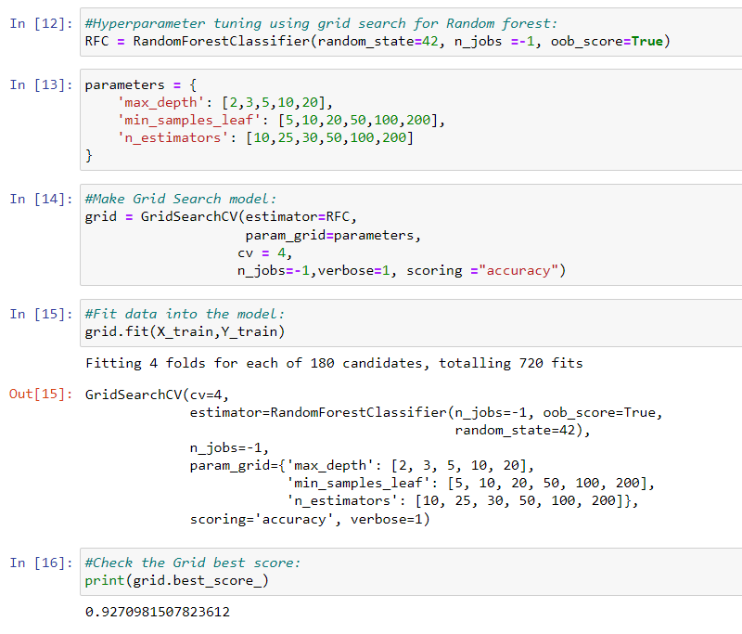

* Using best hyperparameters for the model

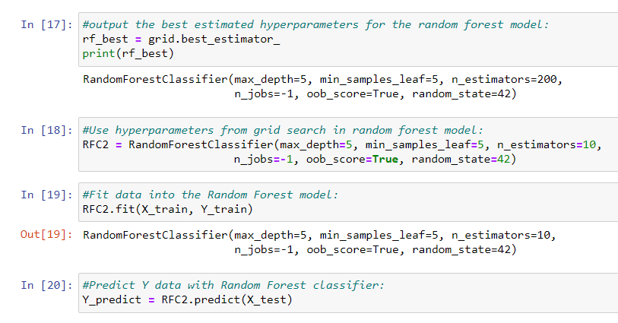

* Results and confusion matrix

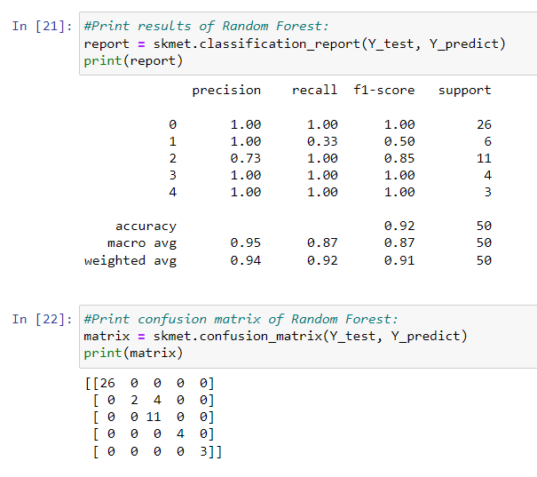

* Conclusion:

**SVM Classification had the best results out of the three classifications used based on the results.**